# CS 255 System Design Document Template

This template lays out all the different sections that you need to complete for Project Two. Each section has guidance to prompt your thinking. You will need to continually reference the interview transcript as you work to make sure that you are addressing your client’s needs. There is no required length for the final document. Instead the goal is to complete each section based on what your client’s needs are. Remove this note when you are finished, and replace all bracketed text with the relevant information.

## UML Diagrams

### UML Use Case Diagram

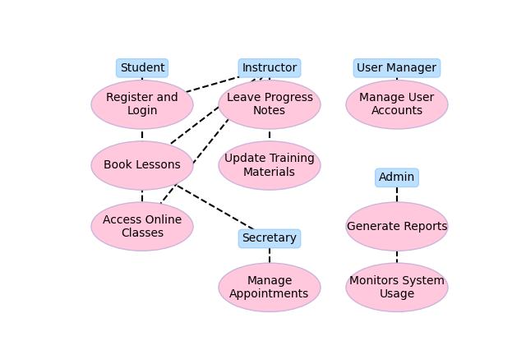

### UML Activity Diagrams

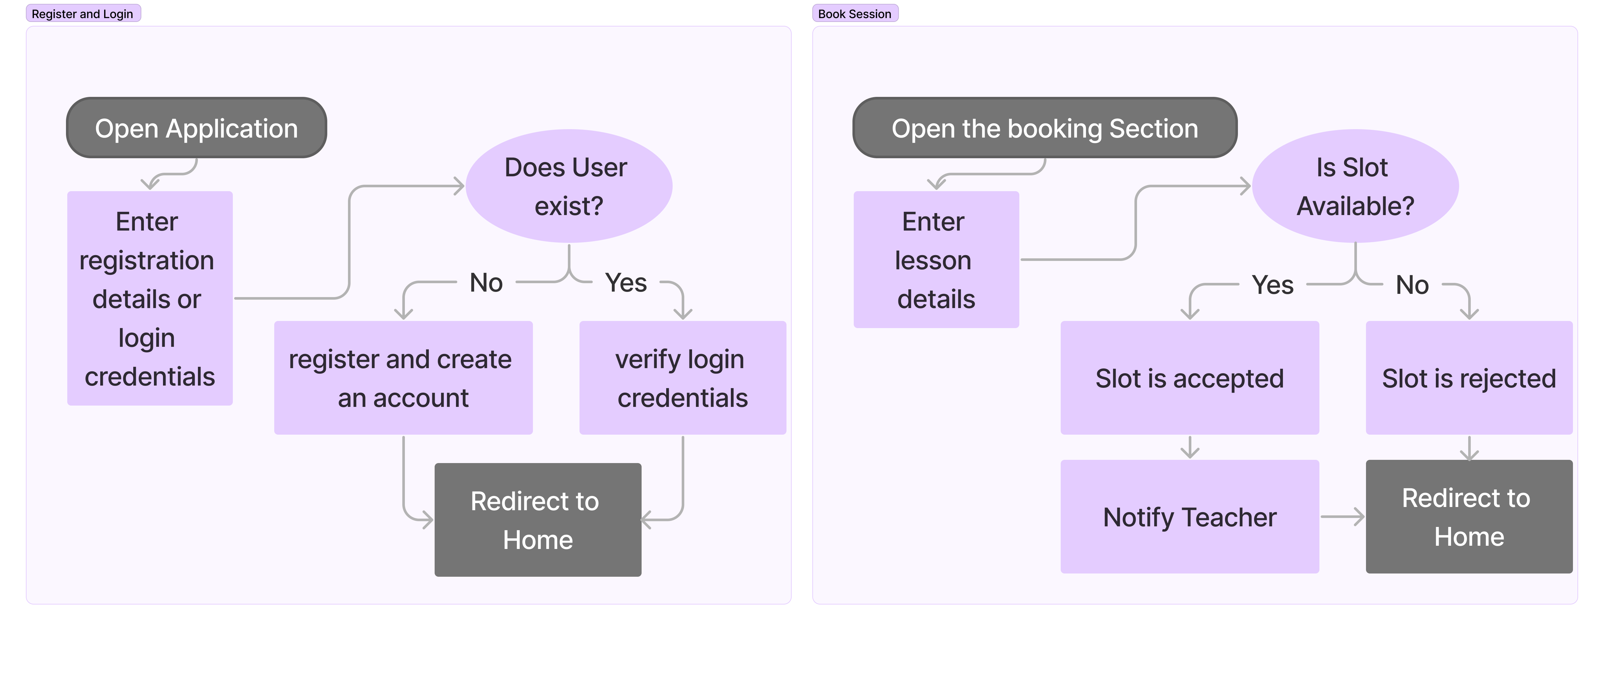

### UML Sequence Diagram

### UML Class Diagram

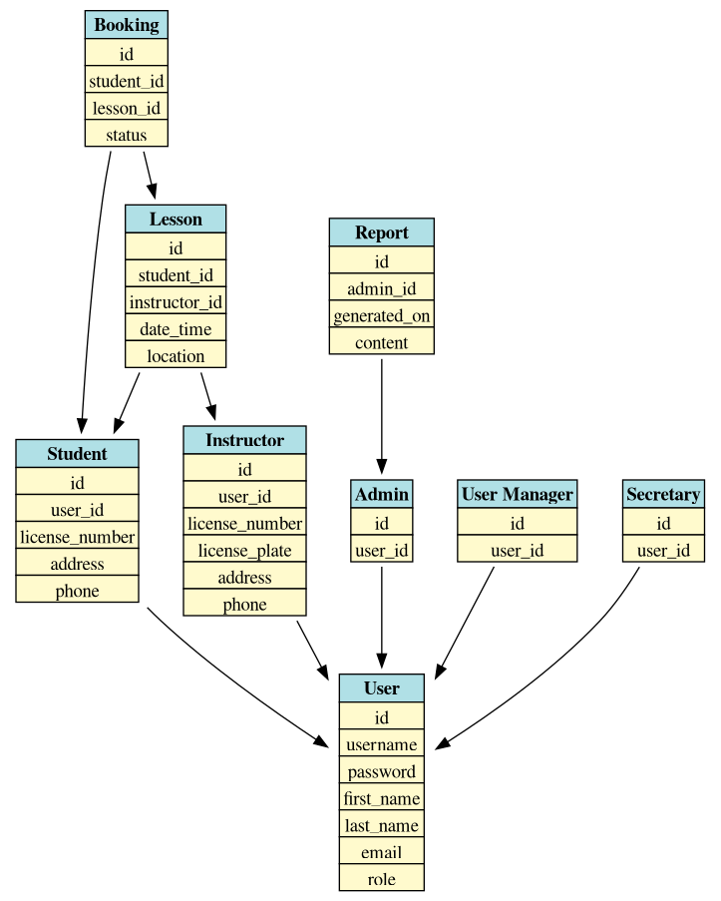

## Technical Requirements

The technical requirements for the DriverPass system, based on the diagrams, rely on both strong hardware and software components for a smooth operation. On the hardware side, the system requires a strong servers capable of handling multiple simultaneous connections, ensuring high availability and responsiveness. These servers should have multiple midrange CPUs or a single high ranged server CPU, like the Intel Xenon or Ryzen Threadripper. The server should also include a large amount of memory, the more memory a server has, the more data it can process in a single transaction. Lastly storage to manage the database operations and user interactions effectively. Additionally, network infrastructure must support secure and fast communication between clients and the server, with reliable internet connectivity to facilitate online data access and modifications. For the client, basic hardware requirements include personal computers, tablets, or smartphones with internet access to interact with the system.

On the software and tools side of the app, the DriverPass backend should be built using a strong, secure, and fast framework like Java Spring-Boot, Rocket.rs, or CrowCPP to ensure efficient handling of HTTP requests and database operations. A relational database management system like PostgreSQL or MySQL is required to store user data, lesson bookings, and other related information. For a frontend development tool, HTMX will be used to create a responsive and user-friendly interface. Designing the app as a Progressive Web App can make it accessible while offline with little to no extra effort. For development and version control, Git is essential. Lastly, the system will incorporate security measures like SSL/TLS for data encryption, role-based access control for managing user permissions, and regular updates from DMV integrated to keep training materials current.